
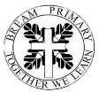
Christian Value: Truthfulness
‘Be the best you can be; together we grow from acorns to oaks, flourishing in God’s love’

Helping all children to become caring, confident and curious young people.
The subject map below shows some of the main areas of learning that will be covered in our class over the Autumn term.

Year 6

World War II and Population Change


English
Our focus class texts this term are One Day by Michael Rosen, The Lost Book of Undersea Adventures by Teddy Keen and Rescuing Titanic by Flora Delargy. We will write diary entries, adventure narratives and letters. We will learn to use semicolons to link main clauses, dashes and commas to show parenthesis, speech punctuation and dashes.

Mathematics
We will begin the Autumn term by learning about place value where we will be able to read and write numbers up to 10,000,000 and round numbers up to 10,000,000. After, we will revisit formal methods for addition, subtract, multiplication and division – including long multiplication and long division. For our fractions unit, we will learn about equivalent fractions, adding and subtracting mixed numbers and multiplying and dividing fractions. We will finish the Autumn term by converting metric measures, calculating miles and kilometres and understanding imperial measures.

Science
In Science, our focus will be studying living things and classifying them. We will extend our learning to find out about the standard system of classification first developed by Carl Linnaeus. Then we will study light and reflection, exploring how light travels in straight lines and that this explains observations of shadows and reflection.

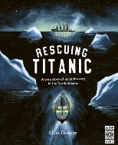
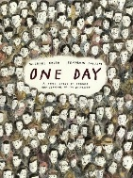
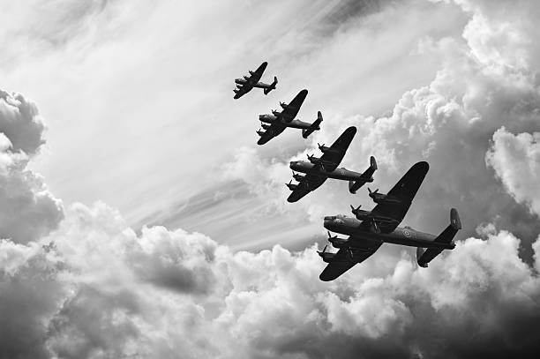
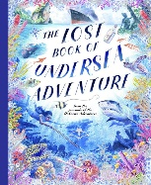
Geography
We will be studying Population change.
Our learning will focus on:
- The changes and distributions of population.
- Changes in birth and death rates.
- Factors that influence migration.
- Impact that climate change can have on the population.
- How population impacts traffic and litter in our local area.

PSHE
We will be learning about working together, negotiating, resolving conflict and being assertive. We will then learn about our differences and how to respect them.

Computing
We will study internet safety and coding using Purple Mash.
RE
We will explore the importance of the Genesis account of creation and how it relates to scientific accounts.
French
We will learn to understand the French for different houses and their rooms.
Music
We will identify how different styles of music contribute to the feel of a film.

PE
This term, we will be developing our ability to attack and defend in football. Then, we will study gymnastics through ‘matching and mirroring’.
PE kits are required every Tuesday.

History
We will be studying World War II
Our learning will focus on:
- The causes of WW2.
- How the Battle of Britain was won.
- Making inferences about the Blitz.
- Understand the emotions and experiences of evacuees.
- Impact of WW2 on women’s lives.
- Discuss why migrants come to Britain.

Art and Design
We will explore the purpose and techniques of street art while developing skills in shading, perspective, scaling, material selection, and spatial design.
Design and Technology
In DT, we will study digital designs by producing a navigational tool for trekkers using CAD software.

Homework and Reading
Homework and Spelling Lists are given out every Friday. Spelling tests take place every Friday. Homework is due in the following Friday and class reward points will be given to pupils who complete and return their homework every week.
Pupils should read at least three times per week at home. Page numbers and comments should be recorded in their reading records. Pupils can also access Story Zoo for reading. TTRS should be accessed daily for short periods of time.

