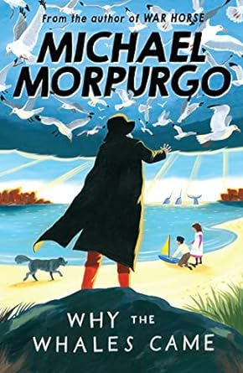
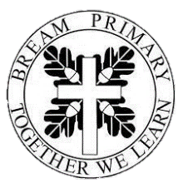
Homework:
Children are expected to read at home as often as possible. We have a class reading chart with rewards for reading at home at least three times a week. Please support your child in doing this and sign their record to show they have read at home. TT Rock stars is set for the children to work on as often as they can. Spellings will be set each week and will be tested at the end of the week.
Science:
This term, we will be learning about materials with a focus on Mixtures and separations. We will then move on to properties and changes. We will continue to devleop our scientific enquiry skills through the use of observationas, record keeping, reporting results, testing, concluding and researching.
Mathematics:
This term we will start with place value and understanding the value of each digit within a number. We will then move on to focus on the key mathematical operations addition, subtraction, multiplication and division. Our work on multiplication and division will then lead into fractions

English
Initially this term, we will be consolidating our prior learning, ensuring that we apply the writing skills we learnt in year 4. We will then move on to study The Man Who Walked Between the Towers by Mordicai Gerstein. We will learn how to write facts files, setting descriptions, letters, persuasive speeches and biographies. We will then read The Odyssey by Gillian Cross and will produce monologues, diary entries, postcards, adverts and finally, an adventure story.

In reading this term we will look at Fortunately, the Milk by Neil Gaiman and Everest by Alexandra Stewart.

an
Christian Value:
Forgiveness
‘Be the best you can be; together we grow from acorns to oaks, flourishing in God’s love.’
Mornings with Mrs Griffin
Year 5

The subject web below shows some of the areas we will be covering in Cedar class throughout the Autumn term.

