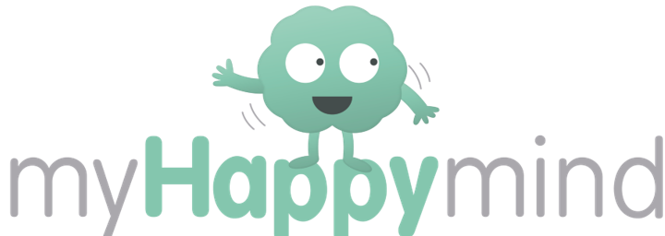


Dear Parents,

We have introduced a program to all year groups at school called myHappymind. myHappymind is all based around helping children to understand how their brain works and to support them in developing positive skills and habits to be their very best selves!

myHappymind is delivered in schools by class teachers through a series of interactive lessons and then the children apply these learnings throughout the day. To further embed this learning and ensure that you are able to engage in these topics with your child, myHappymind has developed a set of resources for parents. These resources can be accessed online on your computer, or through an app on your phone. The resources allow children to continue to practise some of the habits they have developed at school, such as Happy Breathing, for you to learn more about what they are learning in the program. Also included are activities for you to do together at home, to complement the in-school lessons.

To access these materials just go to https://myhappymind.org/parent-resources and enter your name, email, and authentication code. Your authentication code is 148230

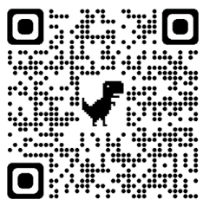
Or scan this QR code to sign up

We really encourage you to make use of this free content so that you can support your child in getting the best out of the curriculum. If you have any questions about the curriculum, please contact your class teacher.

If you have any technical questions about accessing the resources, please contact hello@myHappymind.org
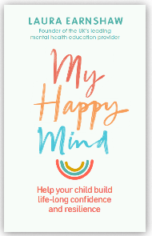
Want to learn more? Check out myHappymind founder Laura Earnshaw’s best selling book on Amazon.

Many thanks,

Lucy Nelmes
SEND and Inclusion Lead
The Severn Federation Academy Trust

